BUSINESS INTELLIGENCE REPORT
Power BI – Online Retail Sales, Customers & Returns
Experiment / Practical Report

Name | Yarasani Renu Lasya Reddy
UID | 24BAI70210
University | Chandigarh University
Program | B.Tech – Artificial Intelligence and Machine Learning

Submitted using the Power BI report and screenshots provided by the student.

1. Aim
To transform online retail transaction data into an interactive Power BI report that presents sales performance, product demand, customer activity, geographical concentration, and return-related information through interactive visualizations.

2. Business Questions
- How much was sold and what was the net sales value?
- Which months and countries contributed most to sales?
- Which products generated the largest sales?
- How many sales orders and known customers were present?
- What is the observed return value and return value rate?
- How does customer identification affect customer-level analysis?

3. Dataset and Scope
The report is based on an Online Retail transaction dataset. The supplied report describes 541,909 original transaction lines and 8 columns, covering transactions from 1 December 2010 to 9 December 2011. Monetary values are treated as GBP.
- InvoiceNo – invoice identifier; cancellation invoices are represented by a leading C.
- StockCode – product or transaction code.
- Description – product label.
- Quantity – signed quantity; positive values represent sales and negative values represent returns/credits.
- InvoiceDate – transaction timestamp.
- UnitPrice – price per unit in GBP.
- CustomerID – customer identifier; missing IDs are treated as Unknown.
- Country – country associated with the transaction.

4. Tools / Software Used
- Microsoft Power BI Desktop
- Power Query for data preparation and transformation
- Power BI Data Model / relationships
- DAX measures for analytical calculations
- Power BI Report View for interactive visualizations

5. Data Preparation and Cleaning
Before building the report, the transaction data was prepared so that the dashboard could present consistent sales and return measures.
Processing Step | Result
Original invoice lines | 541,909
Exact duplicate lines removed | 5,268
Invalid / excluded lines | 2,512
Retained transaction lines | 534,129
Positive-quantity sales | 524,878
Negative-quantity returns/credits | 9,251
Line Amount was calculated as Quantity × Unit Price. Gross Sales use positive sales lines, Return Value uses the absolute value of negative lines, and Net Sales is Gross Sales minus Return Value.

6. Data Model and Relationships
The report uses a star-style model with one fact table and four dimension tables. The screenshots show the following model tables: DimCountry, DimCustomer, DimDate, DimProduct and FactTransactions.
Dimension Key | Fact Table Key
DimDate[Date] | FactTransactions[TransactionDate]
DimProduct[StockCode] | FactTransactions[StockCode]
DimCustomer[CustomerID] | FactTransactions[CustomerID]
DimCountry[Country] | FactTransactions[Country]
The relationships are active, many-to-one from the fact table to the dimension tables, with filtering from dimensions to the fact table.

7. Step-by-Step Procedure Followed in Power BI
Step 1 – Open Power BI Desktop
Open Microsoft Power BI Desktop and open the Online Retail Power BI project/report.
Step 2 – Load / Refresh the Data
Use the prepared data sources and refresh the model so that the dimension tables and FactTransactions table are populated.
Step 3 – Prepare the Data in Power Query
Check data types, remove exact duplicates and exclude invalid records. Handle missing customer and product information using the defined Unknown treatment.
Step 4 – Create the Data Model
Use FactTransactions as the central fact table and connect it to DimDate, DimProduct, DimCustomer and DimCountry.
Step 5 – Create Analytical Measures
Create measures for Gross Sales, Return Value, Net Sales, Sales Orders, Average Order Value, Known Customers, Units Sold, Products Sold, Return Value Rate and Repeat Customer Rate.
Step 6 – Build the Sales Overview Page
Create KPI cards for Gross Sales, Net Sales, Sales Orders and Average Order Value. Add a monthly sales chart, country sales chart, monthly detail table and Month/Country slicers.
Step 7 – Build the Product Performance Page
Create KPI cards for Products Sold, Units Sold, Gross Sales and Return Value Rate. Add a Top 10 Products chart, monthly units-sold chart and product-detail table.
Step 8 – Build the Customers & Markets Page
Create cards for Known Customers, Repeat Customer Rate, Countries Served and Anonymous Sales Share. Add the Top 10 identified customers chart and market-performance details.
Step 9 – Build the Returns & Quality Page
Create cards for Return Value, Return Value Rate, Units Returned and Return Invoices. Add monthly return value and Top 10 product return-value visuals.
Step 10 – Add Interactive Slicers
Use Month and Country slicers to filter the report pages and inspect how the visual values change.
Step 11 – Verify the Report
Clear slicers and selections, compare the full-data KPIs, inspect charts and tables, and check that the report visuals display correctly.
Step 12 – Save the Power BI Report
Save the completed Power BI report as a PBIX file and keep the report screenshots with the submission.

8. Report Screenshots and What Was Done
Figure 1 – Sales Overview
The first report page presents Gross Sales, Net Sales, Sales Orders and Average Order Value cards. It also contains a monthly sales visual, country-level sales visual, monthly performance detail and Month/Country slicers.
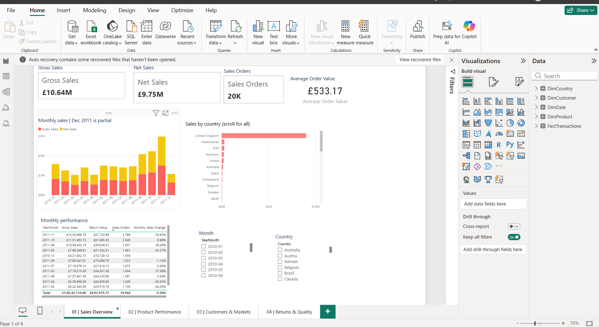

Figure 2 – Product Performance
The second page presents Products Sold, Units Sold, Gross Sales and Return Value Rate. It includes product-level details, Top 10 products by gross sales and monthly units sold.
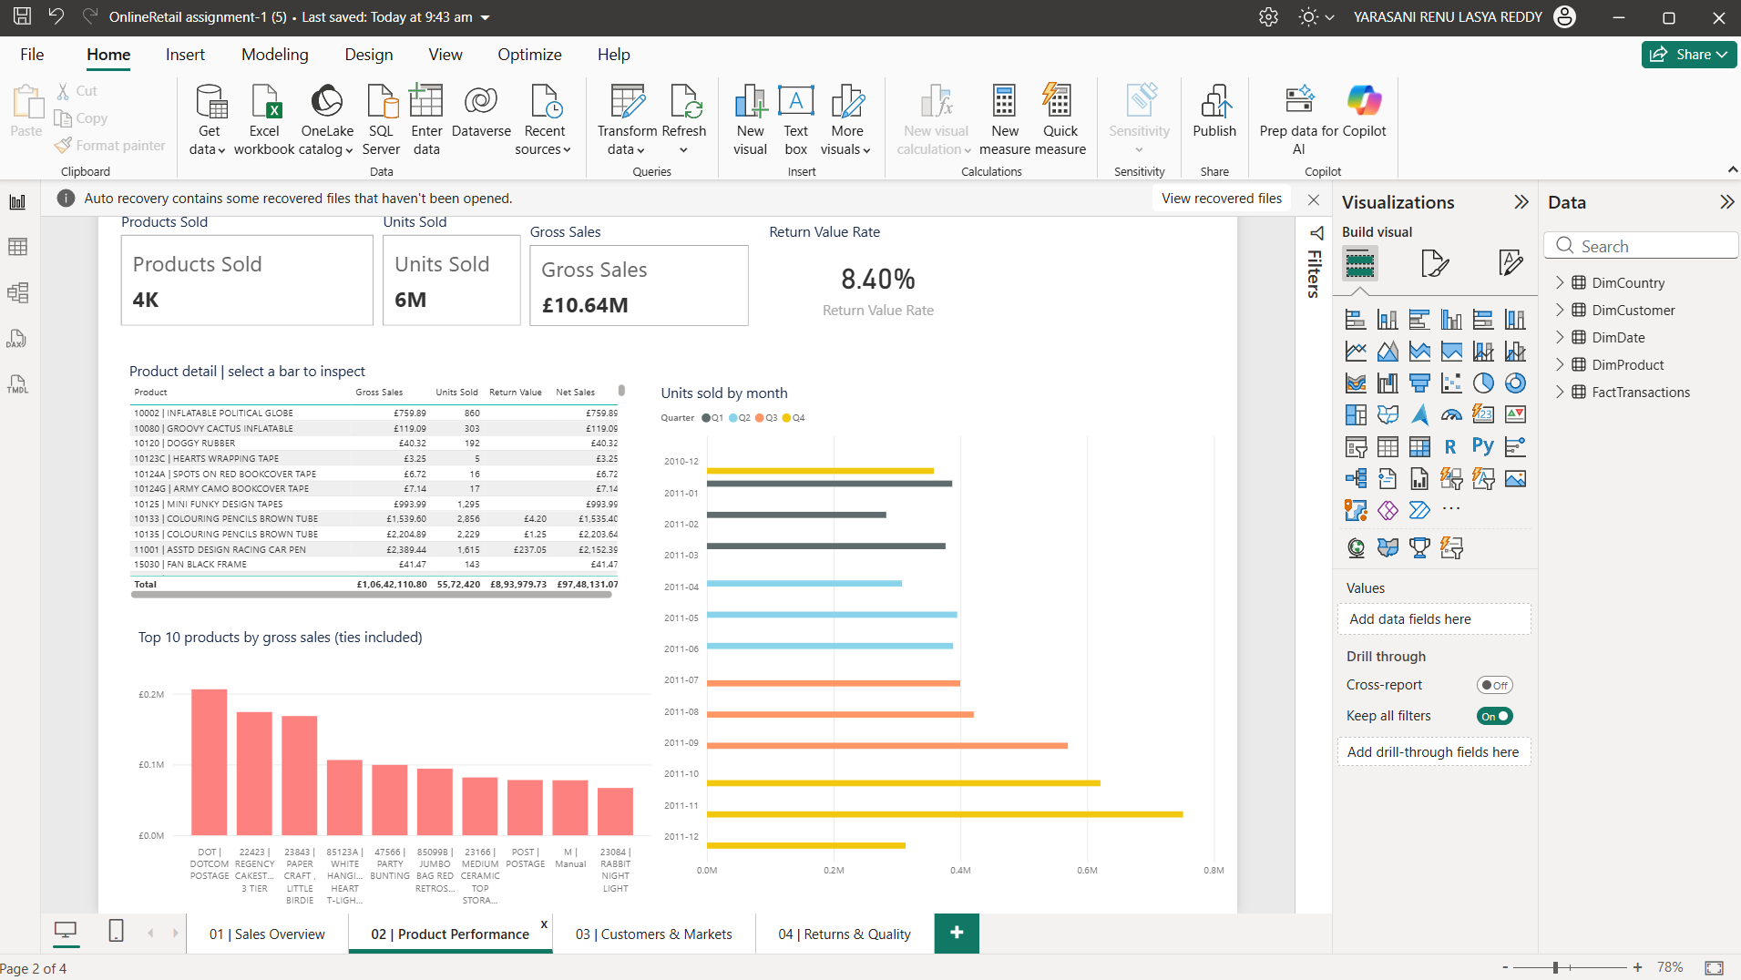

Figure 3 – Customers & Markets
The third page presents Known Customers, Repeat Customer Rate, Countries Served and Anonymous Sales Share. It includes Top 10 identified customers, market performance and country sales.
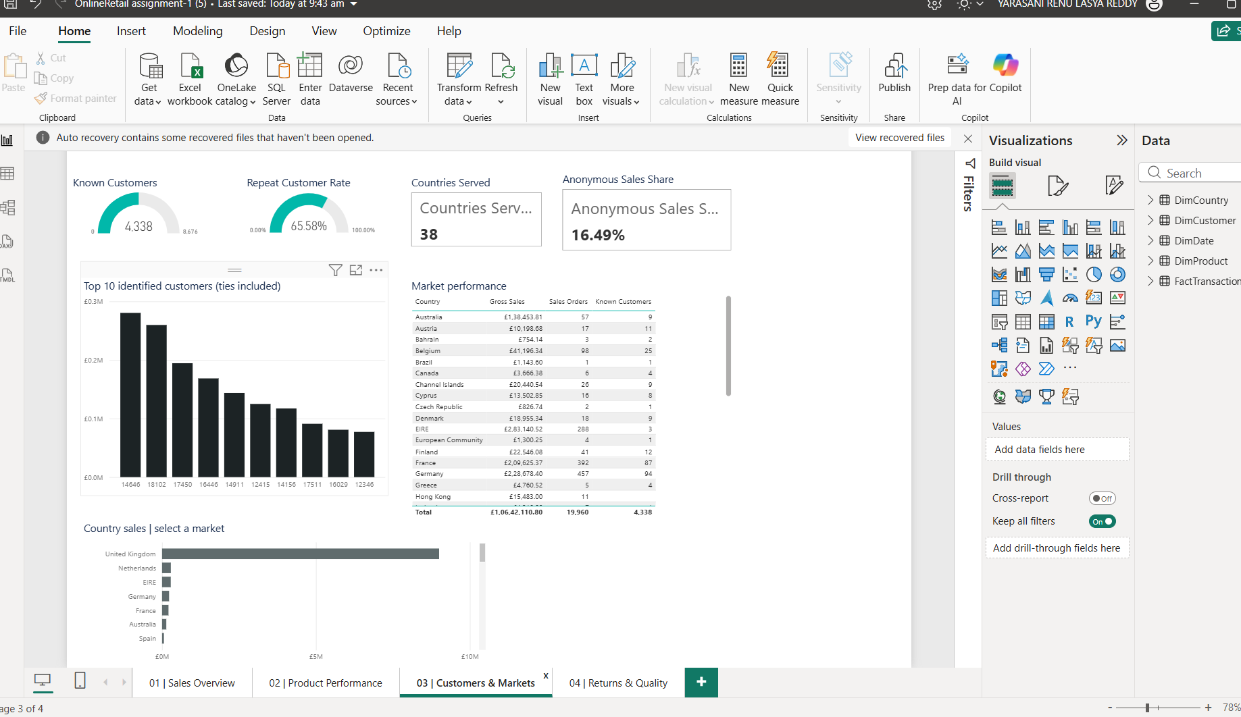

Figure 4 – Returns & Quality
The fourth page presents Return Value, Return Value Rate, Units Returned and Return Invoices. It includes monthly return value, Top 10 product return values, and Month/Country slicers.
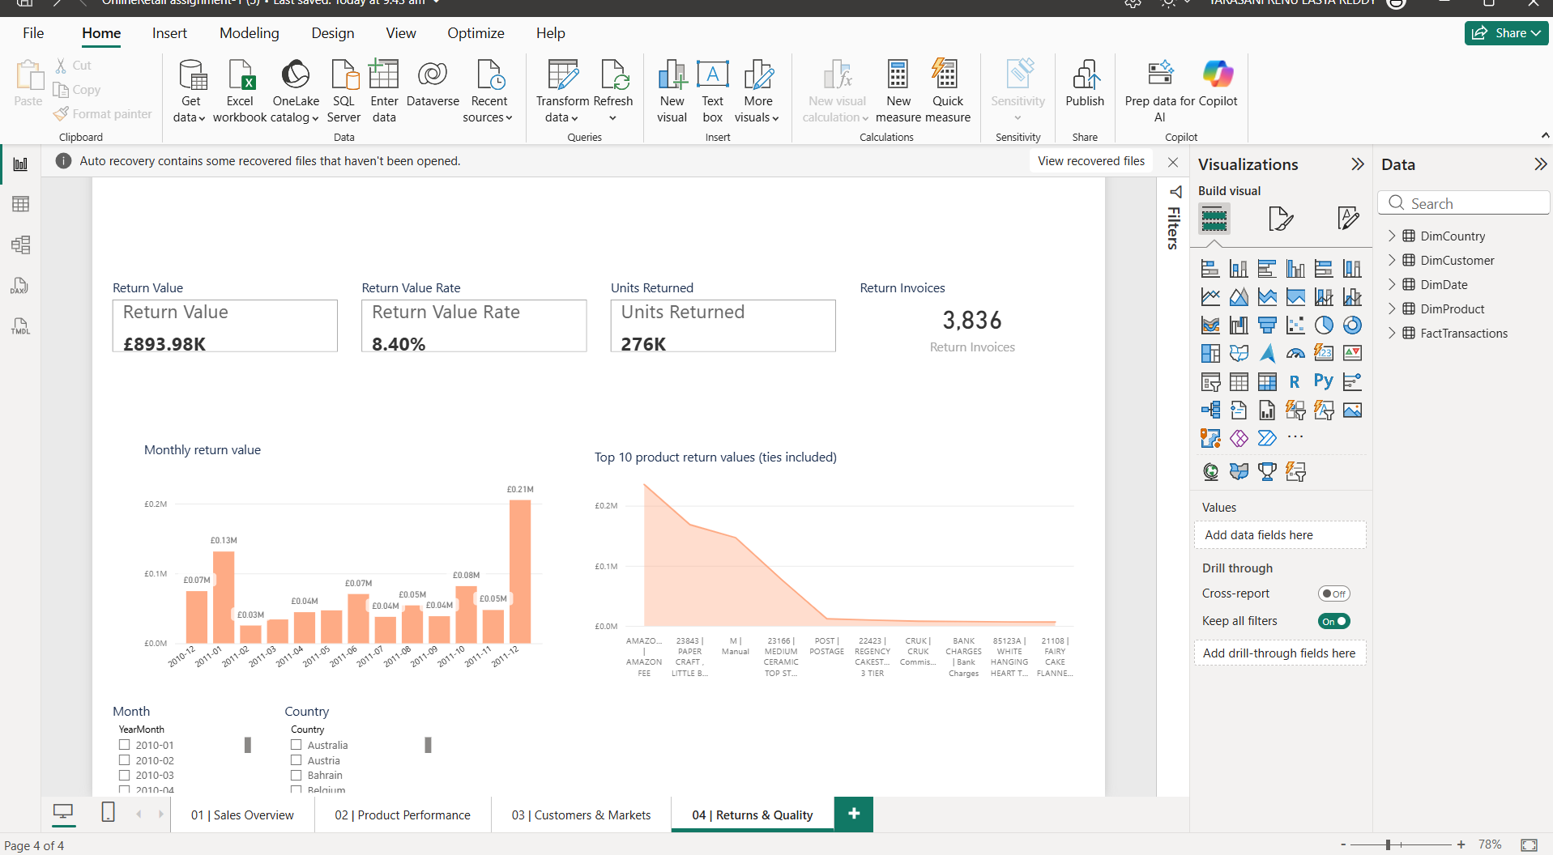

9. Results / Key KPIs
KPI | Observed Value
Gross Sales | GBP 10,642,110.80
Return Value | GBP 893,979.73
Net Sales | GBP 9,748,131.07
Sales Orders | 19,960
Average Order Value | GBP 533.17
Known Customers | 4,338
Units Sold | 5,572,420
Products Sold | 3,922
Countries Served | 38
Return Value Rate | 8.40%
Repeat Customer Rate | 65.58%
Anonymous Sales Share | 16.49%

10. Observations
- The United Kingdom is the dominant sales market, contributing GBP 9,001,744.09 or 84.59% of gross sales.
- November 2011 has the highest observed monthly gross sales at GBP 1,503,866.78 in the supplied snapshot.
- Anonymous sales total GBP 1,754,901.91, so customer-level analysis cannot explain that revenue at an individual customer level.
- The report shows an observed Return Value of GBP 893,979.73 and a Return Value Rate of 8.40%.
- The dataset contains an incomplete December 2011 period, so it should not be treated as a full month.

11. Conclusion
The Power BI report successfully converts the online retail transaction data into an interactive business intelligence report. The completed pages provide a combined view of sales, products, customers, markets and returns. KPI cards provide quick summaries, while charts, tables and slicers support detailed exploration of the data.

12. Learning Outcomes
- Learned how to prepare and transform retail transaction data for analysis.
- Learned how to build a fact-and-dimension data model in Power BI.
- Learned how to create and use DAX measures for business KPIs.
- Learned how to create KPI cards, charts, tables and slicers.
- Learned how to design multiple report pages for different analytical purposes.
- Learned how to interpret sales, customer, market and return information from an interactive report.

13. Reference Basis
This report was prepared from the uploaded Business Intelligence Assignment document and the four Power BI screenshots supplied with the request. The KPI values, data-preparation counts, model relationships and dashboard-page descriptions are taken from the supplied assignment material.

